***BlackJack***

- Complete blackjack _skeleton.py.

- You are supposed to submit the **code** (blackjack_skeleton.py) as well as the **report** explaining your code in details.

- You can submit your work via icampus.

- Deadline of the project is **Dec. 21th 24:00**, and delay is **never** allowed.

- Keep in mind that **delayed work** **will not be accepted.**

1. Understand the game_loop(), blackjack() functions and some classes
   * Cardgraphics class already defined
   * Table class already defined
2. Have to define Card class

* It has 3 attributes that are suit, face, image
  + suit : suit name
  + face : face name
  + image : image object for graphic
* Implement the following methods
  + **__init__**(self, face, suit) : set attributes when the card object is created
  + **__str__**(self) : returns the string of a card (example : "8 of Diamonds").
  + **value**(self) : returns the face value of the card.

1. Have to define Deck class

* It has a attribute that are card
  + card : list of cards in deck that is shuffled
* Implement the following method
  + **__init__**(self) : create a deck of 52 cards and shuffle them
  + draw(self) : draws the top card from the deck.

1. Have to define Hand class

* It has 5 attributes that are canvas, x, y, graphics, hand
  + canvas : canvas object
  + x, y : starting position of cards in his hand
  + graphics : the list of Graphics objects of cards in his hand
  + hand : the list of Card objects of cards in his hand
* Implement the following methods
  + **__init__**(self, x, y, canvas) : create an empty hand displayed at indicated position on canvas
  + **clear**(self) : make hand empty
  + **add**(self, card, hidden = False): adds a new card to his hand.

If hidden == False then add Cardgraphics object of hidden card.

Otherwise add **Cardgraphics** object of visible card

* + **show**(self): makes a hidden card(first card) in his hand visible.
  + **value**(self): computes and returns the total value of the cards in his hand

In the function **ask()** of Table class, there is a statement for handling “keyboard event” (“y” or “n”). To get the sense of it, you can refer to the example code (event_example.py) as well as supplementary.pptx

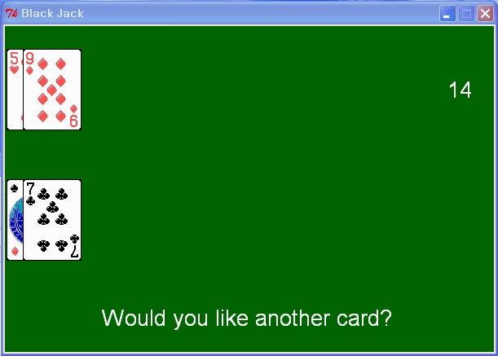 or 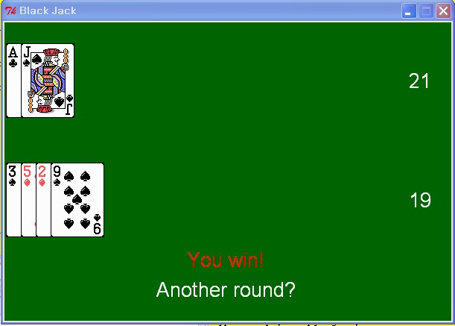

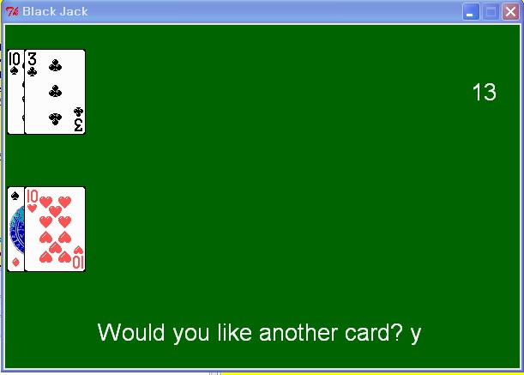 or 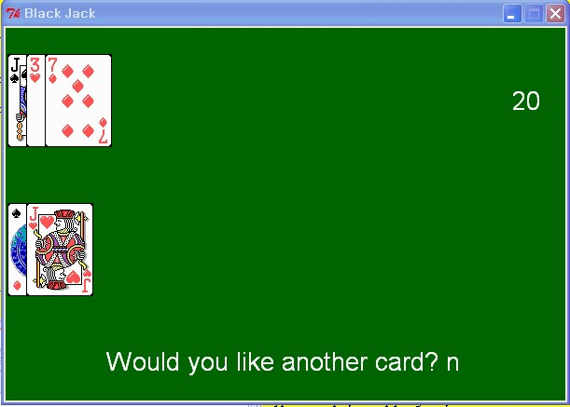

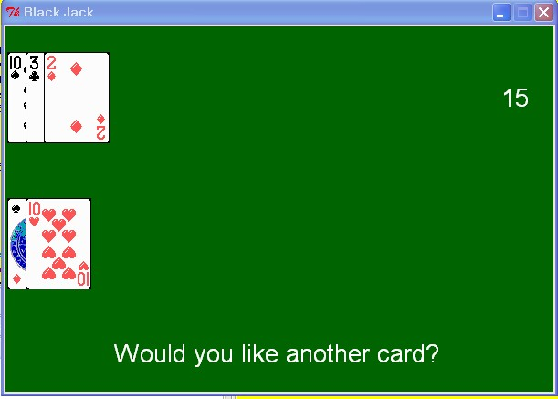 or 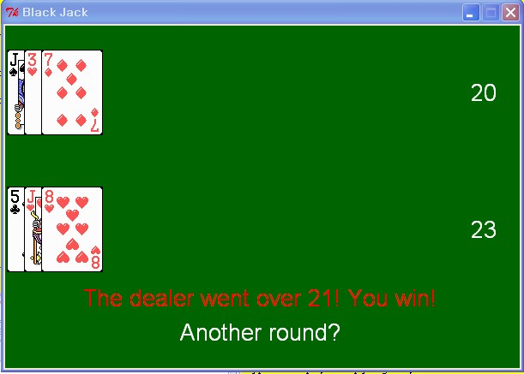

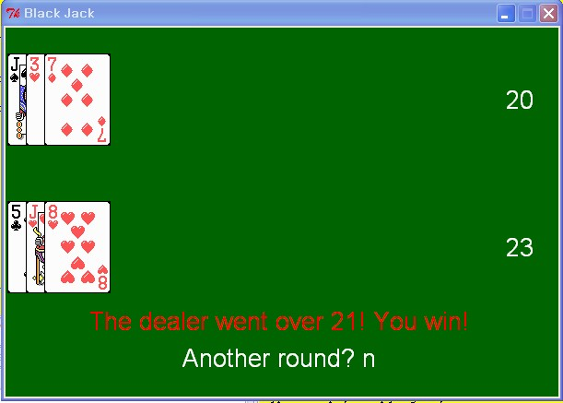 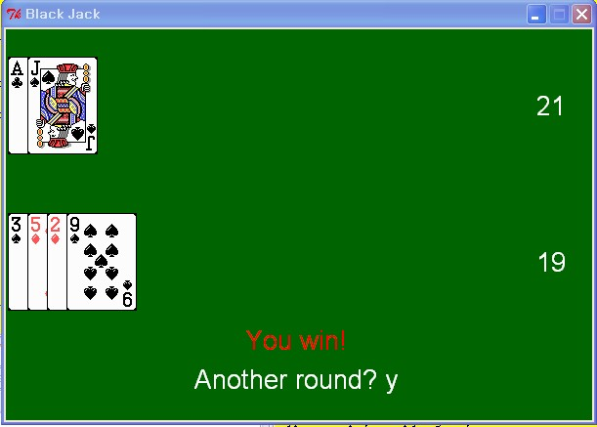

Game is Over Another Game Started